ACADEMOR

INTRODUCTION TO PYTHON

MINI PROJECT

GAME DEVELOPMENT

***Game development*** is the art and science of creating video games. It involves a complex interplay of programming, design, art, and sound to bring interactive experiences to life. From conceptualizing game worlds to writing code, developing characters, and crafting immersive soundtracks, game development is a collaborative process that requires technical skill, creativity, and a deep understanding of player psychology.

Application of Python in game development

***Python*** is widely used in game development due to its simplicity and readability, making it ideal for both prototyping and full-scale development. Popular libraries and frameworks like Pygame, Panda3D, and Ren'Py allow developers to create 2D and 3D games, as well as visual novels. Python is also employed for scripting in larger engines like Unity, and for implementing game logic, AI, and networking. Additionally, Python is used to develop tools and utilities that aid in game development, such as level editors and asset management systems. Its versatility and ease of use make Python a valuable tool in the game development industry.

OPEN CV LIBRARY IN PYTHON

**Python boasts a robust ecosystem for color vision tasks within image processing.** ***OpenCV*** stands out as the most comprehensive library, offering a vast array of tools for color space transformations, detection, and manipulation. It excels in efficiency and versatility, making it suitable for a wide range of applications.

Snakes and Ladders

***Snakes and Ladders*** is a classic board game enjoyed by people of all ages. It's a game of chance where players roll a dice to move their game piece around a board filled with numbered squares.

The goal is to reach the final square at the top of the board. However, the journey is filled with both opportunities and challenges. Landing on a ladder propels you forward, bringing you closer to the finish line. Unfortunately, encountering a snake sends you sliding back to a lower square, delaying your progress.

With its simple rules and exciting twists, Snakes and Ladders has been a beloved pastime for generations.

CODE

import random

print("Welcome to my Game of Snakes and Ladders")

print()

import cv2

grey_image = cv2.imread('Board_snake and ladder.jpg',0)

cv2.imshow('graysale image',grey_image)

cv2.waitKey(0)

cv2.destroyAllWindows()

cv2.imwrite('grayscale.jpg',grey_image)

pos=0

def game(pos):

  print("Press 'R' to roll\n'M' to main menu")

  inp=input(">>")

  while(inp!='M' or inp!='m'):

    dice=random.randint(1,6)

    print("You rolled",dice)

    if(dice==1):

      pos+=1

    if(dice==2):

      pos+=2

    if(dice==3):

      pos+=3

    if(dice==4):

      pos+=4

    if(dice==5):

      pos+=5

    if(dice==6):

      pos+=6

    if(pos==1):

      pos=38

      print("Hooray! Ladder")

    if(pos==4):

      pos=14

      print("Hooray! Ladder")

    if(pos==8):

      pos=30

      print("Hooray! Ladder")

    if(pos==21):

      pos=42

      print("Hooray! Ladder")

    if(pos==28):

      pos=76

      print("Hooray! Ladder")

    if(pos==32):

      pos=10

      print("Ouch...SnakeBite!")

    if(pos==36):

      pos=6

      print("Ouch...SnakeBite!")

    if(pos==48):

      pos=26

      print("Ouch...SnakeBite!")

    if(pos==50):

      pos=67

      print("Hooray! Ladder")

    if(pos==62):

      pos=18

      print("Ouch...SnakeBite!")

    if(pos==71):

      pos=92

      print("Hooray! Ladder")

    if(pos==80):

      pos=99

      print("Hooray! Ladder")

    if(pos==88):

      pos=24

      print("Ouch...SnakeBite!")

    if(pos==95):

      pos=56

      print("Ouch...SnakeBite!")

    if(pos==97):

      pos=78

      print("Ouch...SnakeBite!")

    if(pos==100):

      print("You have Won!!")

      print("Winner Winner, Chicken Dinner")

      break

    if(pos<100):

      print("You are currently at ",pos)

    if(pos>100):

      print("Roll again, It's impossible to move like that")

      pos=pos-dice

      print("You are currently at ",pos)

    inp=input(">>")

print("Press 'S' to start the game\nPress'E' to Exit")

input1=input(">>")

if(input1=='S' or input1=='s'):

  game(pos)

OUTPUT

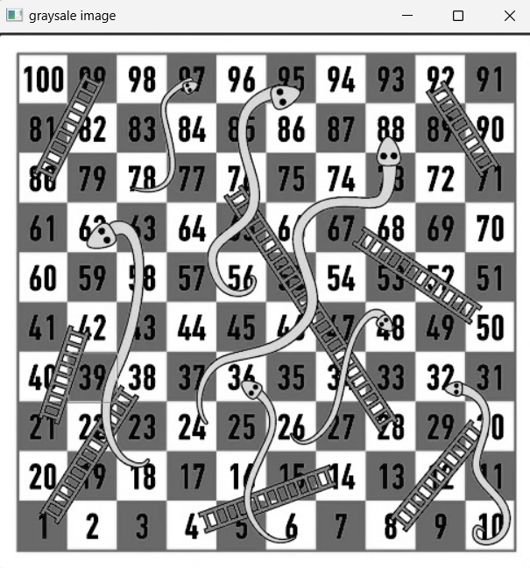

Welcome to my Game of Snakes and Ladders

Press 'S' to start the game

Press'E' to Exit

Press 'R' to roll

'M' to main menu

You rolled 4

Hooray! Ladder

You are currently at 14

You rolled 2

You are currently at 16

You rolled 1

You are currently at 17

You rolled 5

You are currently at 22

You rolled 5

You are currently at 27

You rolled 2

You are currently at 29

You rolled 4

You are currently at 33

You rolled 2

You are currently at 35

You rolled 6

You are currently at 41

You rolled 4

You are currently at 45

You rolled 4

You are currently at 49

You rolled 4

You are currently at 53

You rolled 6

You are currently at 59

You rolled 4

You are currently at 63

You rolled 4

You are currently at 67

You rolled 5

You are currently at 72

You rolled 2

You are currently at 74

You rolled 2

You are currently at 76

You rolled 6

You are currently at 82

You rolled 3

You are currently at 85

You rolled 4

You are currently at 89

You rolled 4

You are currently at 93

You rolled 2

Ouch...SnakeBite!

You are currently at 56

You rolled 4

You are currently at 60

You rolled 1

You are currently at 61

You rolled 2

You are currently at 63

You rolled 6

You are currently at 69

You rolled 4

You are currently at 73

You rolled 5

You are currently at 78

You rolled 5

You are currently at 83

You rolled 3

You are currently at 86

You rolled 4

You are currently at 90

You rolled 4

You are currently at 94

You rolled 3

Ouch...SnakeBite!

You are currently at 78

You rolled 5

You are currently at 83

You rolled 4

You are currently at 87

You rolled 4

You are currently at 91

You rolled 2

You are currently at 93

You rolled 3

You are currently at 96

You rolled 5

Roll again, It's impossible to move like that

You are currently at 96

You rolled 6

Roll again, It's impossible to move like that

You are currently at 96

You rolled 6

Roll again, It's impossible to move like that

You are currently at 96

You rolled 5

Roll again, It's impossible to move like that

You are currently at 96

You rolled 6

Roll again, It's impossible to move like that

You are currently at 96

You rolled 6

Roll again, It's impossible to move like that

You are currently at 96

You rolled 3

You are currently at 99

You rolled 6

Roll again, It's impossible to move like that

You are currently at 99

You rolled 6

Roll again, It's impossible to move like that

You are currently at 99

You rolled 3

Roll again, It's impossible to move like that

You are currently at 99

You rolled 5

Roll again, It's impossible to move like that

You are currently at 99

You rolled 1

You have Won!!

Winner Winner, Chicken Dinner